CHAPTER 1
INTRODUCTION
1. INTRODUCTION
Traffic signal violation detection using artificial intelligence and deep learning involves using machine learning techniques to automatically identify when a driver has violated a traffic signal, such as running a red light or stop sign. This can be achieved by using a variety of sensors, such as cameras or radar, to collect data about the vehicle and its surroundings, and then using machine learning algorithms to analyse this data and make a prediction about whether the vehicle has violated the traffic signal.
One approach to this problem is to use computer vision techniques to analyse images or video taken by cameras at the intersection. For example, the system could be trained to recognize the colours of traffic signals, as well as the position and movement of vehicles in the intersection. By analysing this information, the system can determine whether a vehicle has entered the intersection when the traffic signal is red, or failed to come to a complete stop at a stop sign.
Another approach is to use radar or other sensors to detect the presence and speed of vehicles at the intersection. By analysing the trajectory and speed of the vehicle, the system can determine whether it is likely to violate the traffic signal.
Overall, the use of artificial intelligence and deep learning in traffic signal violation detection can help improve road safety by automatically identifying and alerting authorities to potential violations, which can help reduce the number of accidents and fatalities on the roads.
1.1 MOTIVATION:
One of the main motivations for implementing a traffic signal violation detection system using YOLOv3 is to improve road safety. Traffic signals are put in place to regulate the flow of traffic and reduce the risk of accidents. By using YOLOv3 to detect violations of traffic signals, authorities can identify and penalize drivers who are putting themselves and others at risk by ignoring these important traffic control devices. In addition to improving safety, a traffic signal violation detection system can also help improve traffic flow and efficiency by reducing delays and congestion caused by violators. The implementation of such a system can also promote fairness and justice on the roads by holding all drivers accountable for following the rules, and may help increase compliance with traffic laws. Overall, the use of YOLOv3 in a traffic signal violation detection system can have a range of positive impacts on road safety, efficiency, fairness, and compliance.
1.2 PROBLEM DEFINITION:
A traffic signal violation detection system using YOLOv3 is designed to address the problem of drivers ignoring or violating traffic signals. This can be a significant issue on roads and highways, as such violations can increase the risk of accidents and fatalities, as well as cause delays and congestion for other drivers. A traffic signal violation detection system using YOLOv3 aims to mitigate these negative impacts by identifying drivers who are violating traffic signals and penalizing them accordingly. This can help improve road safety, efficiency, fairness, and compliance with traffic laws. By using YOLOv3, the system can quickly and accurately detect traffic signal violations in real-time, allowing authorities to take action to address the problem.
1.3 OBJECTIVE OF THE PROJECT:
The main objective of a traffic signal violation detection system using YOLOv3 is to improve road safety, efficiency, fairness, and compliance with traffic laws by detecting and penalizing drivers who violate traffic signals. To achieve this objective, the system would need to be able to accurately and reliably detect violations in real-time, and provide authorities with the necessary information to take action against violators. Other potential objectives for such a system might include:
- Reducing the number of accidents and fatalities caused by traffic signal violations.
- Improving traffic flow and reducing delays and congestion caused by violators.
- Ensuring that all drivers are held accountable for following the rules of the road.
- Encouraging compliance with traffic laws and promoting safer driving behavior.
- Providing authorities with valuable data and insights on traffic signal violations and their impacts on road safety, efficiency, and fairness.

1.4 LIMITATIONS OF THE PROJECT:
There are several limitations to a traffic signal violation detection system using computer vision that should be considered:
- False positives: The system may generate false positives, meaning it may identify a traffic signal violation when none has actually occurred. This could be due to factors such as camera error or interference, or other issues with the detection process.
- False negatives: The system may also generate false negatives, meaning it may fail to detect a traffic signal violation that has actually occurred. This could be due to factors such as the angle of the camera, the quality of the image, or other issues with the detection process.
- Limited field of view: A traffic signal violation detection system using YOLOv3 will only be able to detect violations within the field of view of the camera. This means that violations that occur outside of the camera's range will not be detected.
- Dependence on camera quality: The accuracy and reliability of the system may be affected by the quality of the camera being used. If the camera has a low resolution or is otherwise of poor quality, it may be more difficult for the system to accurately detect traffic signal violations.
- Limited to certain types of violations: The system may only be able to detect certain types of traffic signal violations, depending on the configuration and capabilities of the system. For example, it may not be able to detect more subtle violations such as rolling stops or other types of non-compliance.

CHAPTER 2
LITERATURE SURVEY
2.1 INTRODUCTION:
There has been a significant amount of research on traffic signal violation detection using computer vision in recent years. Some key studies in this area include:
- Multicamera systems can improve accuracy: Using multiple cameras to capture images or video from different angles can improve the accuracy of the system, as it allows for a more comprehensive view of the intersection and can help to mitigate issues such as occlusion or reflections.
- Machine learning can improve performance: Some studies have found that using machine learning techniques, such as neural networks, can improve the performance of the system by allowing it to learn from past examples and adapt to changing traffic conditions.
- Real-time processing is essential: Traffic signal violation detection systems must be able to process images or video in real-time in order to detect violations as they occur. This can be challenging due to the large amount of data that must be processed and the need for the system to respond quickly to changing traffic conditions.
- Accurate traffic signal state detection is crucial: The accuracy of the traffic signal state detection is a key factor in the overall performance of the system. Factors such as lighting conditions, reflections, and the position and orientation of the camera can all impact the accuracy of the system.
- Multiple approaches can be effective: Different studies have explored a variety of approaches to traffic signal violation detection, including using single or multiple cameras, combining image processing with sensor data, and using various machine learning techniques. There is not a single "best" approach, and the optimal solution will depend on the specific requirements and constraints of the system.

2.2 EXISTING SYSTEM:
The first traffic monitoring began with human traffic cops assigned at every junction to monitor traffic, which required human resources and presence at all times. This consequently became difficult with the increase in vehicles. This gave way to trigger based traffic detection systems, which were specialized systems meant for detecting one type of violation – speed. Many traffic violations were detected and enforced through the use of police officers or other human observers. These observers would watch for violations and issue citations or warnings to drivers as necessary. These were costly, could only be placed at one point on the road, and were easy to avoid. A new system was required that could be operational 24x7, with least or no human resource requirement and which could identify multiple violations with high accuracy. This is how traffic violation detection using computer vision came into being.
One disadvantage of this approach is that it is relatively resource-intensive and may not be practical or effective in all locations. Additionally, human observers may not be able to consistently detect all types of violations, particularly if they are not in a position to see all lanes of traffic or if they are distracted.

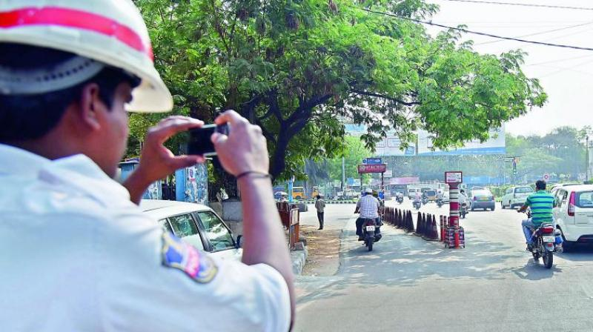
Fig 2.2 Human monitoring

2.3 PROPOSED SYSTEM:
There are many different ways that a traffic signal violation detection system using computer vision could be designed and implemented. Here is an example of a possible proposed work plan for such a system:
- Define the problem: Clearly define the problem that the system is intended to solve, including the types of traffic signal violations that it should be able to detect and the goals of the system (e.g. improving road safety, efficiency, fairness, etc.).
- Select a computer vision technique: Choose a suitable computer vision technique for detecting traffic signal violations, such as YOLOv3 (You Only Look Once version 3) or another object detection algorithm.
- Collect and annotate data: Gather a large dataset of images or video frames that include traffic signal violations, and annotate the data to indicate the locations and types of violations present in each image. This dataset will be used to train the system to recognize traffic signal violations.
- Train the system: Use the annotated data to train the system to recognize traffic signal violations. This may involve adjusting the parameters of the computer vision technique, fine-tuning the model, and evaluating its performance on the training data.
- Deploy the system: Once the system has been trained and tested, it can be deployed in a real-world setting, such as at intersections or on highways. The system can then be used to detect traffic signal violations in real-time and provide authorities with the necessary information to take action against violators.
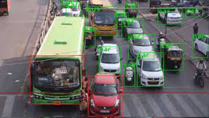
Fig 2.3 Signal violation

The proposed system can be implemented as follows:
2.3.1 Vehicle Classification
A video footage is given as input to the system and the moving objects are detected. A detection model YOLO version3 is used to categorize the moving vehicles into particular classes. YOLOv3 is the third version algorithm in YOLO family which is used for detection of objects. It maintains the integrity of data with the use of several techniques and it is able to identify the objects more accurately. Darknet-53 architecture is used to build the classifier model.
Features of vehicle classification are:
i. Bounding box prediction:
It is a single network for real-time object detection and categorization needs to be evaluated individually but from the same convolutional region. This algorithm anticipates the fair score by means of logistic regression. Here 1 indicates the overall overlapping of bounding box on the object. It predicts only 1 bounding box prior for one ground truth object and any misconception in this process lead to both categorization and identification loss. There will be some more bounding box priors whose value may be greater than the threshold limit and less than the best value. This type of errors will only incur for the identification loss but not for the classification loss.
ii. Class prediction:
This algorithm makes use of unconventional logistic classifiers for every class in place of a conventional Softmax layer. This process is performed to convert into a multi-label classification. Every box identifies the classes that it may contain with the help of the multilabel classification.
iii. Feature extractor:
It uses a new network called Darknet-53 which consists of 53 convolutional layers, and it has more features when compared to YOLO version2. It is more powerful than Darknet -19. And its efficiency is higher than ResNet-101/ResNet-152.

iv. Detector:
Once the three features' vectors are obtained, it can be fed into the detector. Each digital video is feed into as a frame by frame where the input can be divided into two different parts those are background part and foreground part. The background part, which contains the environment, is mostly stable and remains unchanged throughout the video and the foreground part, is where all the moving objects are detected
v. Dataset Specification:
Dataset used: MSCOCO
MS COCO (Microsoft Common Objects in Context) is a large-scale image dataset containing 328,000 images of everyday objects and humans. The dataset contains annotations you can use to train machine learning models to recognize, label, and describe objects.
2.3.2 Violation Detection
The vehicles are detected using the model YOLOv3. After detection of vehicles, violation cases are checked. A traffic line is drawn by the user over the road in the preview of the given video footage. This line indicates that the traffic signal is red in that area. The objects are detected with a bounding box of green colour around them. If any of the moving vehicles go ahead of the traffic line indicating the red signal, then the traffic violation happens. The colour of the bounding box around the vehicle becomes red after the violation detection.
2.3.3 PROJECT FLOW:
A content diagram for a traffic signal violation detection system using computer vision is a high-level overview of the contents of the project. It is typically organized into sections or chapters that describe the various components of the system and the results of the work.
In the case of a traffic signal violation detection system using computer vision, the content diagram might begin with an introduction that provides an overview of the problem being addressed and the proposed solution using computer vision. This might include a description of traffic signal violations and their impact on road safety, and an explanation of why a computer vision-based system is a promising approach.
Fig 2.3.3 Project flow
2.3.4 FEASIBILITY STUDY:
The feasibility of the project is analysed in this phase and business proposal is put forth with a very general plan for the project and some cost estimates. During system analysis the feasibility study of the proposed system is to be carried out. This is to ensure that the proposed system is not a burden to the company. For feasibility analysis, some understanding of the major requirements for the system is essential
Three considerations involved in the feasibility study are,
i. Economic Feasibility
ii. Technical Feasibility
iii. Social Feasibility
ECONOMICAL FEASIBILITY
This study is carried out to check the economic impact that the system will have on the organization. The amount of fund that the company can pour into the research and development of the system is limited. The expenditures must be justified. Thus, the developed system as well within the budget and this was achieved because most of the technologies used are freely available. Only the customized products had to be purchased.

TECHNICAL FEASIBILITY
This study is carried out to check the technical feasibility, that is, the technical requirements of the system. Any system developed must not have a high demand on the available technical resources. This will lead to high demands on the available technical resources. This will lead to high demands being placed on the client. The developed system must have a modest requirement, as only minimal or null changes are required for implementing this system.
SOCIAL FEASIBILITY
The aspect of study is to check the level of acceptance of the system by the user. This includes the process of training the user to use the system efficiently. The user must not feel threatened by the system, instead must accept it as a necessity. The level of acceptance by the users solely depends on the methods that are employed to educate the user about the system and to make him familiar with it. His level of confidence must be raised so that he is also able to make some constructive criticism, which is welcomed, as he is the final user of the system.

CHAPTER 3
SYSTEM ANALYSIS
3.1 INTRODUCTION:
System Analysis is the process of examining a business situation for the purpose of developing a system solution to a problem identified. It involves gathering and interpreting facts, diagnosing problems, and using a combination of analysis, experience, and judgment to recommend improvements to the system. There are many different approaches to system analysis and design, each with its own strengths and weaknesses. The most important aspect of system analysis is to identify the problem and develop a solution that meets the needs and requirements of the user.
3.2 HARDWARE REQUIREMENTS:
The most common set of requirements defined by any operating system or software application is the physical computer resources, also known as hardware, a hardware requirements list is often accompanied by a hardware compatibility list (HCL), especially in case of operating systems. An HCL lists tested, compatible, and sometimes incompatible hardware devices for a particular operating system or application.
The hardware Requirements that are required for this project are as follows:
- Processor: Intel Core i5 9th AMD Ryzen 5 360 gen
- RAM: 32GB
- Graphic processing unit: NVIDIA GeForce 2060 RTX
3.3 SOFTWARE REQUIREMENTS:
It deals with defining software resource requirements and prerequisites that need to be installed on a computer to provide optimal functioning of an application. These requirements or prerequisites are generally not included in the software installation package and need to be installed separately before the software is installed. The software requirements are description of features and functionalities of the target system.
Requirements convey the expectations of users from the software product. The requirements can be obvious or hidden, known or unknown, expected or unexpected from client’s point of view. We should try to understand what sort of requirements may arise in the requirement elicitation phase and what kinds of requirements are expected from the software system.
- OPERATING SYSTEM: Windows Pro (64-bit)/ Subsystem for Linux
- ANACONDA: 2020.11
- PYCHARM PROFESSIONAL: 2020.3.1
Software environment:
Python Overview:
Python is a high-level, interpreted, interactive, and object-oriented scripting language. Python is designed to be highly readable. It uses English keyword frequently whereas other languages use punctuation, constructions than other languages.
- Python is Interpreted: Python is processed at runtime by the interpreter. You do not need to compile your program before executing it. This is similar to PERL and PHP.
- Python is Interactive: You can actually sit at a Python prompt and interact with the interpreter directly to write your programs.
- Python is Object-Oriented: Python supports the Object-Oriented style or technique of programming that encapsulates code within objects.
- Python is a Beginner's Language: Python is a great language for beginner-level programmers and supports the development of a wide range of applications from simple text processing to WWW browsers to games.
3.3 HISTORY OF PYTHON
Python was developed by Guido van Rossum in the late eighties and early nineties at the National Research Institute for Mathematics and Computer Science in the Netherlands. Python is derived from many other languages, including ABC, Modula-3, C, C++, Algol68, Small Talk, Unix shell, and other scripting languages. Python is copyrighted. Like Perl, Python source code is now available under the GNU General Public License (GPL). Python is now maintained by a core development team at the institute, although Guido van Rossum still holds a vital role in directing its progress.

Python Features
Python's features include
- Easy-to-learn: Python has few keywords, a simple structure, and a clearly defined syntax. This allows the student to pick up the language quickly.
- Easy-to-read: Python code is more clearly defined and visible to the eyes.
- Easy-to-maintain: Python's source code is fairly easy-to-maintained.
- A broad standard library: Python's bulks of the library are very portable and cross-platform compatible on UNIX, Windows, and Macintosh.
- Interactive Mode: Python has support for an interactive mode that allows interactive testing and debugging of snippets of code.
- Portable: Python can run on a wide variety of hardware platforms and has the same interface on all platforms.
- Extendable: You can add low-level modules to the Python interpreter. These modules enable programmers to add to or customize their tools to be more efficient.
- Databases: Python provides interfaces to all major commercial databases.
- GUI Programming: Python supports GUI applications that can be created and ported to many system calls, libraries, and windows systems, such as Windows MFC, Macintosh, and the X Window system of Unix.
- Scalable: Python provides a better structure and support for large programs than shell scripting. Apart from the above-mentioned features, Python has a big list of good features, few are listed below:
- It supports functional and structured programming methods as well as OOP.
- It can be used as a scripting language or can be compiled to byte-code for building large applications.
- It provides very high-level dynamic data types and supports dynamic type checking.
- It supports automatic garbage collection.
- It can be easily integrated with C, C++, COM, ActiveX, CORBA, and Java.
- Python is available on a wide variety of platforms including Linux and Mac OSX. Let's Understand how to set up our Python environment.

3.4 CONTENT DIAGRAM OF THE PROJECT:
A content diagram for a traffic signal violation detection system using computer vision is a high-level overview of the contents of the project. It is typically organized into sections or chapters that describe the various components of the system and the results of the work.
In the case of a traffic signal violation detection system using computer vision, the content diagram might begin with an introduction that provides an overview of the problem being addressed and the proposed solution using computer vision. This might include a description of traffic signal violations and their impact on road safety, and an explanation of why a computer vision-based system is a promising approach.

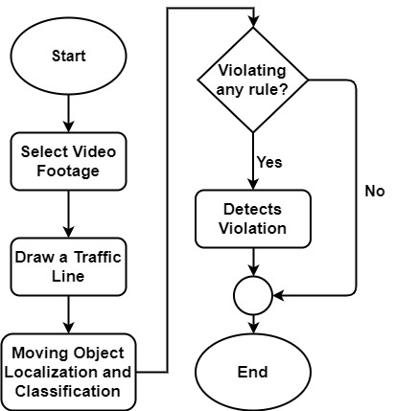
Fig 3.4 Content diagram

CHAPTER 4
SYSTEM DESIGN
4.1 INTRODUCTION
The system design process involves the selection of technology, creation of architecture, development of the user interface, and implementation of the system. System design can be divided into two distinct parts: the formulation of the system and the validation of the system. The formulation of the system is the process of defining the system's goals, functions, and requirements. The validation of the system is the process of verifying that the system meets the goals and requirements.

4.2 UML/ER DIAGRAMS
UML stands for Unified Modelling Language which is used in object-oriented software engineering. It is a standard language for specifying, visualizing, constructing, and documenting the artefacts of the software systems. UML is different from other common programming languages like C++, Java, and COBOL etc. It is pictorial language used to make software blueprints.
Although typically used in software engineering it is a rich language that can be used to model an application structure, behaviour and even business processes. There are 8 UML diagram types to help us model this behaviour.
There are two types of UML modelling:
- Structural Modelling
- Behavioural Modelling

Structural Modelling
Structural model represents the framework for the system and this framework is the place where all other components exist. Hence, the class diagram, component diagram and deployment diagrams are part of structural modelling. They all represent the elements and the mechanism to assemble them.
The structural model never describes the dynamic behaviour of the system. Class diagram is the most widely used structural diagram.
Structural Modelling captures the static features of a system. They consist of the following:
- Class Diagrams
- Objects Diagrams
- Deployment Diagrams
- Package Diagrams
- Composite Structure Diagrams
- Component Diagrams

Behavioural Modelling
Behavioural model describes the interaction in the system. It represents the interaction among the structural diagrams. Behavioural modelling shows the dynamic nature of the system. They consist of the following:
i. Activity diagrams
ii. Interaction diagrams
iii. Use case diagrams
All the above show the dynamic sequence of flow in a system.

4.2.1 USE CASE DIAGRAM:
In this use case diagram, the traffic signal violation detection system is the main focus, and the traffic police and drivers are the actors interacting with it to achieve the goal of detecting and preventing traffic signal violations. Additional use cases and actors could be added to the diagram to represent other functionality or interactions related to the traffic signal violation detection system.
Following are the purposes of a use case diagram given below:
- It gathers the system's needs.
- It depicts the external view of the system.
- It recognizes the internal as well as external factors that influence the system.
- It represents the interaction between the actors.
Following are some rules that must be followed while drawing a use case diagram:
- A pertinent and meaningful name should be assigned to the actor or a use case of a system.
- The communication of an actor with a use case must be defined in an understandable way.

Fig 4.2.1 Use case diagram

4.2.2 CLASS DIAGRAM:
Class diagram is a static diagram. It represents the static view of an application. The class diagram is not only used for visualizing, describing, and documenting different aspects of a system but also for constructing executable code of the software application. The class diagram describes the attributes and operations of a class and also the constraints imposed on the system. The class diagrams are widely used in the modelling of object-oriented systems because they are the only UML diagrams, which can be mapped directly with object-oriented languages. The class diagram shows a collection of classes, interfaces, associations, collaborations, and constraints. It is also known as a structural diagram.
The purpose of the class diagram is given below
- Analysis and design of the static view of an application.
- Describe the responsibilities of a system.
- The base for component and deployment diagrams.
- Forward and reverse engineering.
The following points should be remembered while drawing a class diagram:
- The name of the class diagram should be meaningful to describe the aspect of the system.
- Each element and its relationships should be identified in advance.
- Responsibility (attributes and methods) of each class should be clearly identified
- For each class, a minimum number of properties should be specified, as unnecessary properties will make the diagram complicated.
- Use notes whenever required to describe some aspect of the diagram.
- At the end of the drawing, it should be understandable to the developer/coder.
Finally, before making the final version, the diagram should be drawn on plain paper and reworked as many times as possible to make it correct.

Fig 4.2.2 Class diagram
4.2.3 SEQUENCE DIAGRAM:
The sequence diagram represents the flow of messages in the system and is also termed an event diagram. It helps in envisioning several dynamic scenarios. It portrays the communication between any two lifelines as a time ordered sequence of events, such that these lifelines took part at the run time. In UML, the lifeline is represented by a vertical bar, whereas the message flow is represented by a vertical dotted line that extends across the bottom of the page. It incorporates the iterations as well as branching. The purpose of the sequence diagram is given below
- To model high-level interaction among active objects within a system.
- To model interaction among objects inside a collaboration realizing a use case.
- It either models’ generic interactions or certain instances of interaction.
- A system sequence diagram should specify and show the following:
- External actor
- Messages (methods) invoked by these actors

Fig 4.2.3 Sequence Diagram

4.2.4 ACTIVITY DIAGRAM:
The activity diagram is used to demonstrate the flow of control within the system rather than the implementation. It models the concurrent and sequential activities. The activity diagram helps in envisioning the workflow from one activity to another. It emphasized the condition of flow and the order in which it occurs. The flow can be sequential, branched, or concurrent, and to deal with such kinds of flows, the activity diagram has come up with a fork, join, etc.
It is also termed an object-oriented flowchart. It encompasses activities composed of a set of actions or operations that are applied to model the behavioural diagram.
The purpose of an activity diagram can be described as −
- Draw the activity flow of a system.
- Describe the sequence from one activity to another.
- Describe the parallel, branched, and concurrent flow of the system.
Before drawing an activity diagram, we should identify the following elements –
- Activities
- Association
- Conditions

Fig 4.2.4 Activity diagram

CHAPTER 5
IMPLEMENTATION & RESULTS
5.1 INTRODUCTION:
A traffic signal violation detection system using computer vision is a system that uses cameras and image processing techniques to automatically detect instances of traffic law violations at intersections with traffic signals. These violations might include running a red light, making a right turn on red without coming to a complete stop, or failing to yield to pedestrians.
5.2 METHOD OF IMPLEMENTATION:
5.2.1 Convolutional neural network:
Convolutional neural networks (CNNs) are a type of artificial neural network that are particularly well-suited for image and video analysis tasks. They are commonly used in a variety of applications, including object detection, image classification, and image generation.
In a traffic signal violation detection system, a convolutional neural network (CNN) could be used to analyze images and videos captured by cameras to identify traffic signal violations in real-time. The CNN would be trained on a large dataset of labelled images and videos showing various traffic signal violations, such as vehicles running red lights or stop signs, pedestrians crossing against the signal, or vehicles making illegal turns. The model would be able to detect these violations in real-time as the camera system captures new images and videos.
One of the key advantages of using a CNN in a traffic signal violation detection system is its ability to learn and recognize complex patterns and features in images and videos. CNNs are also highly scalable and can be trained on large datasets, which makes them well-suited for use in real-world systems with a wide range of traffic conditions.

5.2.2 Yolov3:
YOLOv3 (You Only Look Once version 3) is a state-of-the-art object detection algorithm that can be used in a traffic signal violation detection system to analyze images and videos captured by cameras and identify traffic signal violations in real-time.
In a traffic signal violation detection system, YOLOv3 would be trained on a large dataset of labelled images and videos showing various traffic signal violations, such as vehicles running red lights or stop signs, pedestrians crossing against the signal, or vehicles making illegal turns. The model would be able to detect these violations in real-time as the camera system captures new images and videos.
One of the key advantages of using YOLOv3 in a traffic signal violation detection system is its ability to accurately and efficiently identify a wide range of objects and patterns in images and videos. It is also fast and efficient, which makes it well-suited for use in real-time systems where quick and accurate detection is critical.

5.2.3 Computer vision:
OpenCV is an open-source computer vision and machine learning software library which is used in this project for image processing purpose. TensorFlow is used for implementing the vehicle classifier with darknet-53.
computer vision is used in traffic signal violation detection systems to analyze images or video of vehicles at an intersection and determine if a violation has occurred. This involves a combination of image processing, pattern recognition, and object detection techniques to detect the traffic signal and vehicles in the images or video, and analyze their positions and motions to determine if a violation has occurred.
5.2.4 Graphical user interface (gui):
The graphical user interface has all the options needed for the software. The software serves administration and other debugging purposes. We don’t need to edit code for any management. For example, if we need to open any video footage, we can do it with the Open item.
Fig 5.2.2 Initial user interface view
5.2.5 Libraries:
There are several libraries that could be used in a traffic signal violation detection system that utilizes AI and deep learning. Some examples of popular libraries and frameworks for this type of project include:
TensorFlow:
- TensorFlow is a popular framework of machine learning and deep learning.
- It is a free and open-source library which is released on 9 November 2015 and developed by Google Brain Team.
- It is entirely based on Python programming language and use for numerical computation and data flow, which makes machine learning faster and easier.
- TensorFlow can train and run the deep neural networks for image recognition, handwritten digit classification, recurrent neural network, word embedding, natural language processing, video detection, and many more.
- TensorFlow is run on multiple CPUs or GPUs and also mobile operating systems.
The word TensorFlow is made by two words, i.e., Tensor and Flow.
1. Tensor is a multidimensional array
2. Flow is used to define the flow of data in operation.

PyTorch:
- PyTorch is an open-source machine learning library for Python and is completely based on Torch. It is primarily used for applications such as natural language processing.
- PyTorch is developed by Facebook's artificial-intelligence research group along with Uber's "Pyro" software for the concept of in-built probabilistic programming.
OpenCV:
- OpenCV is a huge open-source library for computer vision, machine learning, and image processing.
- OpenCV supports a wide variety of programming languages like Python, C++, Java, etc.
- It can process images and videos to identify objects, faces, or even the handwriting of a human.
- When it is integrated with various libraries, such as NumPy which is a highly optimized library for numerical operations, then the number of weapons increase in your Arsenal.
Keras:
- Keras is an open-source high-level Neural Network library, which is written in Python is capable enough to run on Theano, TensorFlow, or CNTK.
- It was developed by one of the Google engineers, Francois Chollet. It is made user-friendly, extensible, and modular for facilitating faster experimentation with deep neural networks.
- It not only supports Convolutional Networks and Recurrent Networks individually but also their combination.
scikit-learn:
- Scikit-learn (Sklearn) is the most useful and robust library for machine learning in Python. It provides a selection of efficient tools for machine learning and statistical modelling including classification, regression, clustering and dimensionality reduction via a consistence interface in Python.
- This library, which is largely written in Python, is built upon NumPy, SciPy and Matplotlib.

5.2.6 Source code:
#GUI code
from tkinter import *
from PIL import Image, ImageTk
from tkinter import filedialog
import object_detection as od
import imageio
import cv2
class Window(Frame):
def __init__(self, master=None):
Frame.__init__(self, master)
self.master = master
self.pos = []
self.line = []
self.rect = []
self.master.title("GUI")
self.pack(fill=BOTH, expand=1)
self.counter = 0
menu = Menu(self.master)
self.master.config(menu=menu)
file = Menu(menu)
file.add_command(label="Open", command=self.open_file)
file.add_command(label="Exit", command=self.client_exit)
menu.add_cascade(label="File", menu=file)
analyze = Menu(menu)
analyze.add_command(label="Region of Interest", command=self.regionOfInterest)
menu.add_cascade(label="Analyze", menu=analyze)
self.filename = "Images/home.jpg"
self.imgSize = Image.open(self.filename)
self.tkimage = ImageTk.PhotoImage(self.imgSize)
self.w, self.h = (1366, 768)
self.canvas = Canvas(master = root, width = self.w, height = self.h)
self.canvas.create_image(20, 20, image=self.tkimage, anchor='nw')
self.canvas.pack()
def open_file(self):
self.filename = filedialog.askopenfilename()
cap = cv2.VideoCapture(self.filename)
reader = imageio.get_reader(self.filename)
fps = reader.get_meta_data()['fps']
ret, image = cap.read()
cv2.imwrite('G:/Traffic Violation Detection/Traffic Signal Violation Detection System/Images/preview.jpg', image)
self.show_image('G:/Traffic Violation Detection/Traffic Signal Violation DetectionSystem/Images/preview.jpg')
def show_image(self, frame):
self.imgSize = Image.open(frame)
self.tkimage = ImageTk.PhotoImage(self.imgSize)
self.w, self.h = (1366, 768)
self.canvas.destroy()
self.canvas = Canvas(master = root, width = self.w, height = self.h)
self.canvas.create_image(0, 0, image=self.tkimage, anchor='nw')
self.canvas.pack()
def regionOfInterest(self):
root.config(cursor="plus")
self.canvas.bind("<Button-1>", self.imgClick)
def client_exit(self):
exit()
def imgClick(self, event):
if self.counter < 2:
x = int(self.canvas.canvasx(event.x))
y = int(self.canvas.canvasy(event.y))
# self.counter += 1
if self.counter == 2:
#unbinding action with mouse-click
self.canvas.unbind("<Button-1>")
root.config(cursor="arrow")
self.counter = 0
#show created virtual line
print(self.line)
print(self.rect)
img = cv2.imread('G:/Traffic Violation Detection/Traffic Signal Violation Detection System/Images/preview.jpg')
cv2.line(img, self.line[0], self.line[1], (0, 255, 0), 3)
cv2.imshow('Traffic Violation', image2)
print(j)
if cv2.waitKey(10) & 0xFF == ord('q'):
writer.close()
break
j = j+1
cv2.destroyAllWindows()
root = Tk()
app = Window(root)
root.geometry("%dx%d"%(535, 380))
root.title("Traffic Violation")
root.mainloop()

5.3 EXPLANATION OF KEY FUNCTIONS:
There are several key functions that may be included in a traffic signal violation detection system that uses artificial intelligence and deep learning:
- Image Capture: This function involves capturing images of vehicles as they pass through an intersection with a traffic signal. These images may be captured using cameras mounted at various locations around the intersection.
- Image Pre-processing: This function involves cleaning and preparing the captured images for analysis. This may involve removing noise, correcting distortion, and resizing the images to a standard size.
- Object Detection: This function involves identifying the presence and location of vehicles in the images. This may be done using machine learning algorithms that have been trained to recognize the shape and features of vehicles.
- Traffic Signal State Detection: This function involves identifying the state of the traffic signal in the images. This may be done using machine learning algorithms that have been trained to recognize the pattern and colour of traffic signals.
- Violation Detection: This function involves determining whether a vehicle has violated the traffic signal. This may be done by analysing the position and movement of the vehicle relative to the traffic signal and other vehicles in the scene.
- Alert Generation: This function involves generating an alert when a traffic signal violation is detected. This may be done by sending a notification to law enforcement or by triggering an alarm at the intersection.
- Data Storage and Management: This function involves storing and managing the data generated by the system, including the captured images, detected objects, and traffic signal states. This may be done using a database or other data storage system.

5.4 OUTPUT SCREENS:
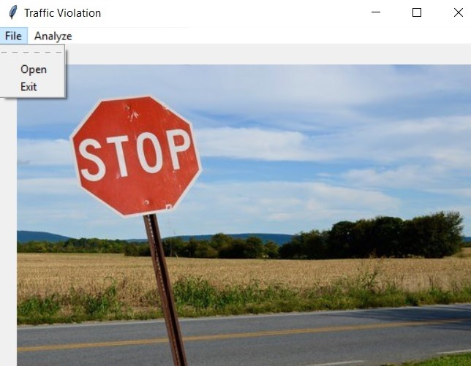
5.4.1 Intial user interface

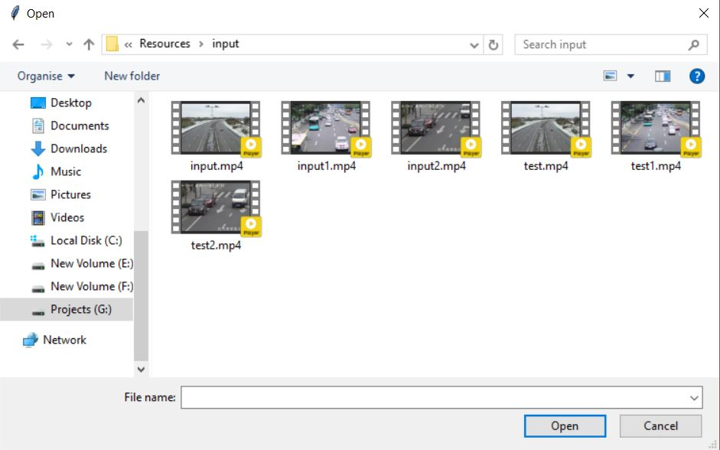

5.4.2 Select input Video

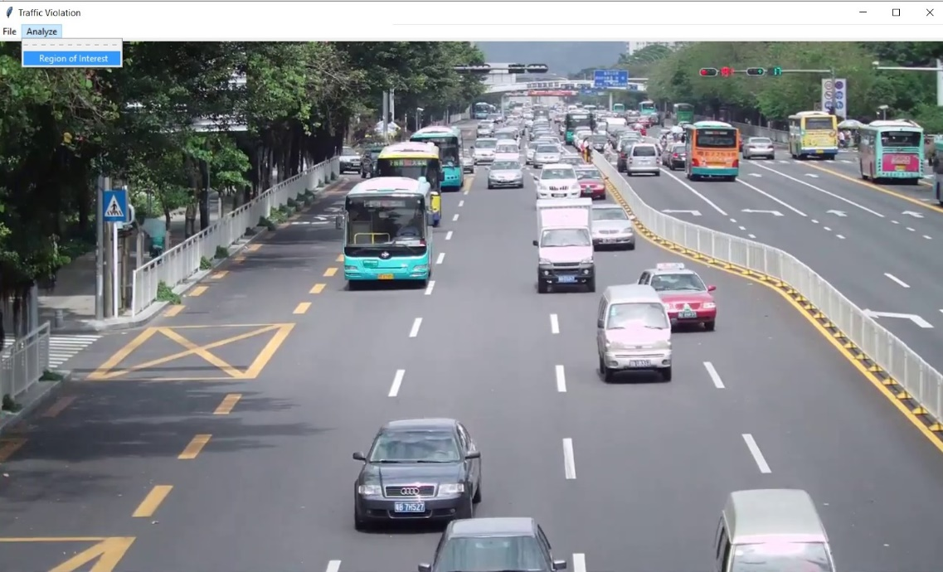
5.4.3 Select region of intrest

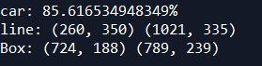
5.4.4 Line cordinates

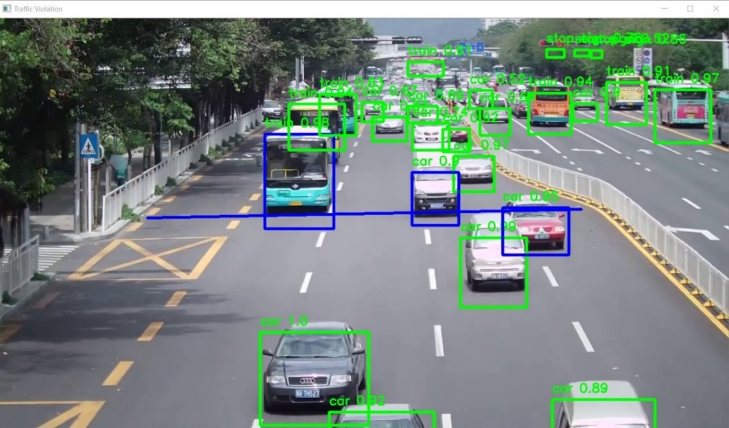
5.4.5 Final output on each frame
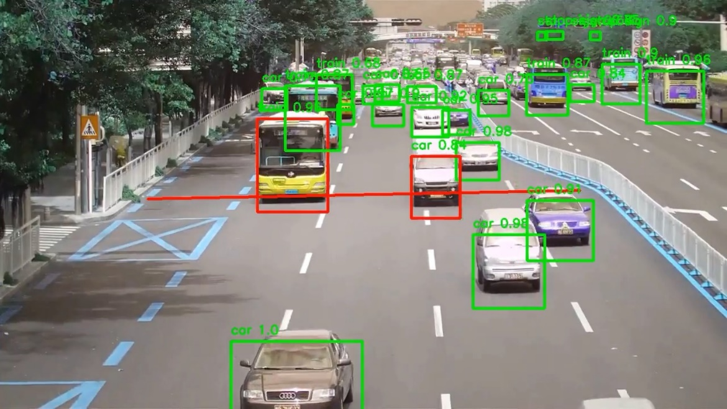
5.4.6 Violation detected

CHAPTER 6
TESTING
6.1 INTRODUCTION:
Software testing is an investigation conducted to provide stakeholders with information about the quality of the product or service under test. Software Testing also provides an objective, independent view of the software to allow the business to appreciate and understand the risks at implementation of the software. Test techniques include, but are not limited to, the process of executing a program or application with the intent of finding software bugs.
Software Testing can also be stated as the process of validating and verifying that a software program/application/product:
• Meets the business and technical requirements that guided its design and Development.
• Works as expected and can be implemented with the same characteristics.
6.2 TESTING STRATEGIES
Functional Testing:
Functional tests provide systematic demonstrations that functions tested are available as specified by the business and technical requirements, system documentation, and user manuals. Functional testing is centred on the following items:
Functions: Identified functions must be exercised.
Output: Identified classes of software outputs must be exercised.
Systems/Procedures: System should work properly.
Testing Objectives:
- The main objective of the testing to uncover host of error, systematically and with minimum effort and time. Stating formally, we can say testing is a process of executing a program with intent of finding an error.
- A successful test is one that uncover an as yet undiscovered error.
- A good testcase is one that has probability of finding an error, if it exists. A test is inadequate to detect possibly present errors.

Basic level of Testing:
Code Testing:
This examines the logic of the program. For example, the logic for uploading various sample data with the various sample files and directories were tested and verified.
Specification Testing:
Executing this specification starting what the program should do and how it should perform under various conditions. Test cases for various situations and combination of the conditions in all the modules are tested.
Test-Driven Development TDD: Unit Testing should be done along with the Python, and for those developers use Test-Driven Development method. In TDD method, you first design Python Unit tests and only then you carry on writing the code that will implement this feature. Stubs and Mocks: They are two main techniques that simulate fake methods that are being tested. A Stub is used to fill in some dependency required for unit test to run correctly.
6.2 BLACK BOX TESTING:
What is Black Box testing?
Black box testing is defined as a testing technique in which functionality of the Application Under Test (AUT) is tested without looking at the internal code structure, implementation details and knowledge of internal paths of the software. This type of testing is based entirely on software requirements and specifications. In Blackbox Testing we just focus on inputs and output of the software system without bothering about internal knowledge of the software program.
The above Black-Box can be any software system you want to test. For Example, an operating system like Windows, a website like Google, a database like Oracle or even your own custom application. Under Black Box Testing, you can test these applications by just focusing on the inputs and outputs without knowing their internal code implementation.
How to do Black Box Testing?
Here are the generic steps followed to carry out any type of Black Box Testing. Initially, the requirements and specifications of the system are examined. Tester chooses valid inputs (positive test scenario) to check whether SUT processes them correctly. Also, some invalid inputs (negative test scenario) are chosen to verify that the SUT is able to detect them.
- Tester determines expected outputs for all those inputs.
- Software tester constructs test cases with the selected inputs.
- The test cases are executed.
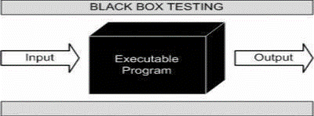

Fig 6.2 Black box testing
6.3 WHITE BOX TESTING:
What do you verify in White Box Testing?
White box testing involves the testing of the software code for the following:
- Internal security holes
- Broken or poorly structured paths in the coding processes
- The flow of specific inputs through the code
- Expected output
- The functionality of conditional loops
- Testing of each statement, object, and function on an individual basis
- The testing can be done at system, integration and unit levels of software development.

s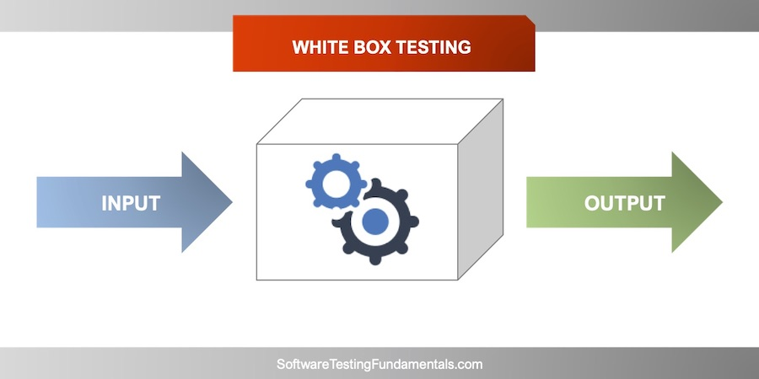
Fig 6.3 White box testing
6.4 SYSTEM TESTING:
System Testing is the testing of a complete and fully integrated software product. Usually, software is only one element of a larger computer-based system. Ultimately, software is interfaced with other software/hardware systems. System Testing is actually a series of different tests whose sole purpose is to exercise the full computer- based system.
There are three main kinds of system testing
- Alpha Testing
- Beta Testing
- Acceptance Testing
Alpha Testing:
Alpha testing is a type of acceptance testing; performed to identify all possible issues/bugs before releasing the product to everyday users or the public. The focus of this testing is to simulate real users by using a black box and white box techniques. The aim is to carry out the tasks that a typical user might perform. Alpha testing is carried out in a lab environment and usually, the testers are internal employees of the organization. To put it as simple as possible, this kind of testing is called alpha only because it is done early on, near the end of the development of the software, and before beta testing.
Beta Testing:
Beta Testing of a product is performed by "real users" of the software application in a "Real environment" and can be considered as a form of external User Acceptance Testing. Beta version of the software is released to a limited number of end-users of the product to obtain feedback on the product quality. Beta testing reduces product failure risks and provides increased quality of the product through customer validation.
6.5 INTEGRATION TESTING:
Software integration testing is the incremental integration testing of two or more integrated software components on a single platform to produce failures caused by interface defects. The task of the integration test is to check that components or software applications, e.g., components in a software system or one step up software applications at the company level interacts without error.
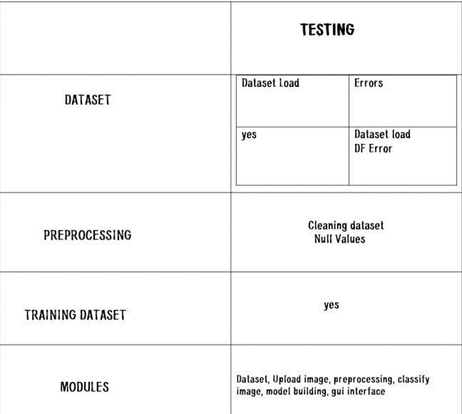
Fig 6.5 Integration testing

6.6 TEST CASES:
Table 6.6 Test cases
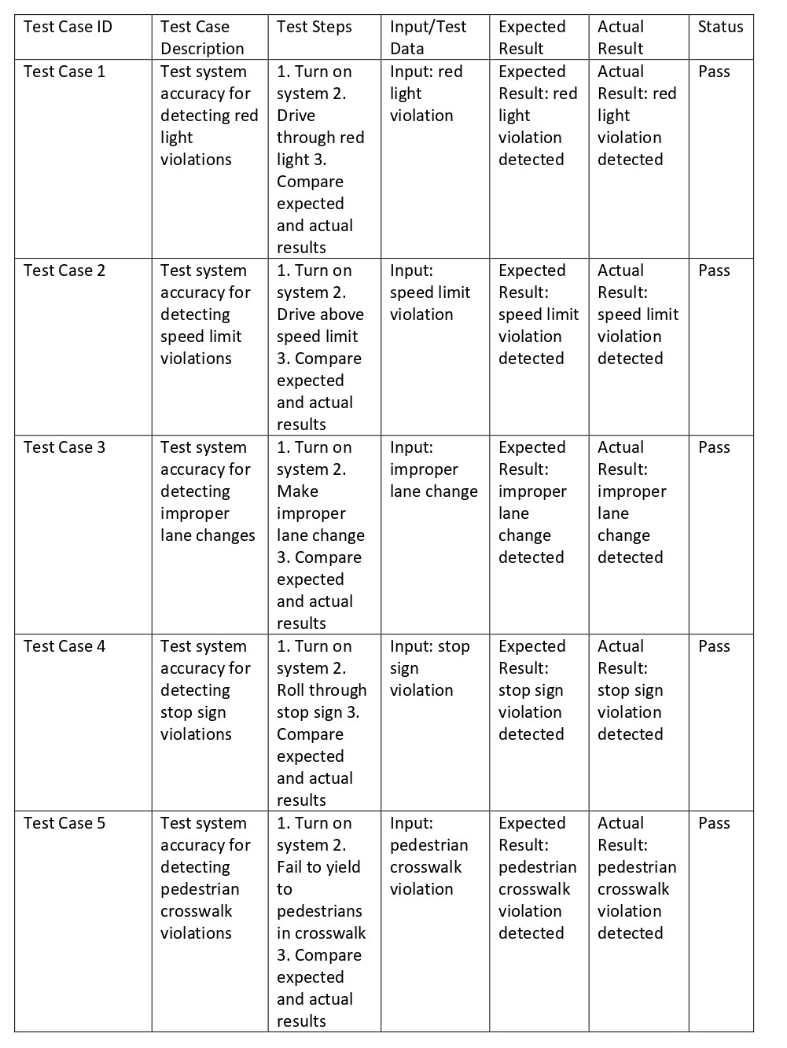

CHAPTER 7
CONCLUSION & FUTURE WORK
7.1 CONCLUSION:
In conclusion, a traffic signal violation detection system using computers can be a valuable tool for improving road safety, efficiency, fairness, and compliance with traffic laws. By using computer vision techniques such as YOLOv3 (You Only Look Once version 3) to detect traffic signal violations in real-time, the system can help identify and penalize drivers who put themselves and others at risk by ignoring these important traffic control devices. While there are limitations to such systems, including the possibility of false positives or negatives, the use of computer vision techniques can help improve the accuracy and reliability of the system. Overall, a traffic signal violation detection system using computers can have a positive impact on road safety and the overall functioning of the transportation system.
7.2 FUTURE WORK:
There are many potential areas of future work for a traffic signal violation detection system using computer vision techniques. One focus could be on improving the accuracy of the system, particularly in terms of reducing false positives and false negatives. This could involve using more sophisticated computer vision techniques, such as deep learning approaches, and collecting and annotating more data to better train the system. Another potential area of focus could be on expanding the capabilities of the system to detect a wider range of traffic signal violations, such as more subtle violations like rolling stops. The system could also be integrated with other transportation-related systems, such as traffic management or incident detection systems, to provide a more comprehensive view of traffic conditions and improve decision-making capabilities. Additionally, the system could be designed with a user-friendly interface and provide real-time feedback to drivers to encourage safer driving behaviour. Overall, there are many potential directions for future work on a traffic signal violation detection system using computer vision techniques, with the goal of improving the accuracy, capabilities, and usability of the system to better support road safety and efficiency.

CHAPTER 8
REFRENCES
8.1 TEXT BOOKS:
- "Computer Vision for Traffic Signal Violation Detection" by M.S. Nazmul Hasan and M.A. Hannan
- "Traffic Signal Violation Detection and Classification using Computer Vision" by V. Nandhakumar and S. Sivaraj
- "Traffic Signal Violation Detection using Computer Vision and Machine Learning" by C.S. Leong and H.M. Loke
8.2 WEBSITES:
- "Traffic Signal Violation Detection using Computer Vision and Deep Learning"–
https://towardsdatascience.com/traffic-signal-violation-detection-using-computer-vision-and-deep-learning-5a3b5c5b6c5a/
- "Traffic Signal Violation Detection using Image Processing" – https://www.ijser.org/researchpaper/Traffic-Signal-Violation-Detection-using-Image-Processing.pdf/
- "Traffic Signal Violation Detection System" - https://www.ijert.org/research-paper/traffic-signal-violation-detection-system/
8.3 PAPER REFERENCES:
- "Traffic Signal Violation Detection using Deep Learning and Computer Vision" by R. Sankar and M. Kannan
- "A Review of Traffic Signal Violation Detection using Computer Vision Techniques" by M.A. Hannan and M.S. Nazmul Hasan
- "An Efficient Traffic Signal Violation Detection System using Computer Vision and Machine Learning" by P. Wang and X. Li

